**Project Design Phase-II**

**Data Flow Diagram & User Stories**

|  |  |
| --- | --- |
| Date | 15 November 2023 |
| Team ID | Team-591881 |
| Project Name | River Water Quality Forecasting |
| Maximum Marks | 4 Marks |

**Data Flow Diagrams:**

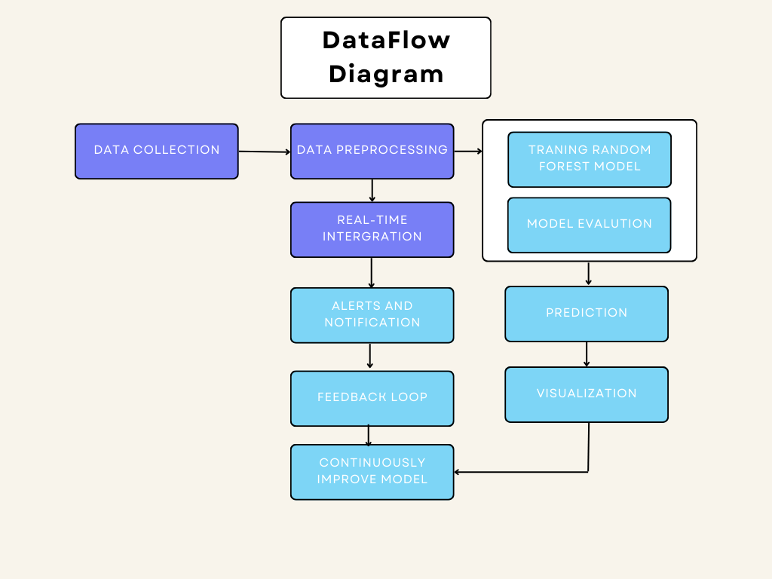

**User Stories**

Use the below template to list all the user stories for the product.

|  |  |  |  |  |  |  |
| --- | --- | --- | --- | --- | --- | --- |
| **User Type** | **Functional**  **Requirement**  **(Epic)** | **User Story Number** | **User Story / Task** | **Acceptance criteria** | **Priority** | **Release** |
| Customer  (Mobile user) | Registration | USN-1 | As a user, I can say I am getting accurate result. | I can access my dashboard | High | Sprint-1 |
|  |  | USN-2 | As a user, I am reliable how it safes my life everytime. | I can access my dashboard | High | Sprint-1 |
|  |  | USN-3 | Now we can easily supply water which we don’t have any idea whether it is safe or not | I can access my dashboard | Low | Sprint-2 |
|  |  | USN-4 | I am checking water status before drinking it | I can access my dashboard | Medium | Sprint-1 |
|  | Login | USN-5 | Safe to drink water now | I can access my dashboard | High | Sprint-1 |
|  | Dashboard |  | I am checking water status before drinking it |  |  |  |
| Customer (Web user) |  |  |  |  |  |  |
| Customer Care Executive |  |  |  |  |  |  |
| Administrator |  |  |  |  |  |  |